# A Merchants Quest

Executive Summary:

A Merchants Quest is a ¾ view strategy game designed by bitRaid Games.

# Key features:

* Accounting-based RPG system – The denizens of this world are in peril, and it is up to the player to save them with their knowledge of accounting and finance. As players learn more and achieve mastery over the basics, they will be able to take on even greater challenges.
* Comprehensive real-world economy - The world will feature a resource system in which goods never leave the economic cycle, with players able to observe the process from start to end.
* Intricate trade system – Goods aren’t always made where they are desired, and it is up to the player to ensure that goods flow where they are needed most, and where the most profit may be earned.
* Seamless microworld blending of education and games – A merchants Quest operates under the design philosophy that immersion learning is the most effective method to teach difficult topics. The result is a game where players are so focused on having fun, they don’t realize that they are learning.

# Design Philosophy

Having an understanding of economics and finance is a huge advantage in the business world, and sadly many individuals are reluctant to learn as it is a topic that has traditionally been seen as intimidating and brutally dry. A Merchant’s Quest attempts to allow individuals a starting point with which to gain an understanding of the core systems and their practices, from which the player may then advance toward a state of complete mastery. While the game will be following

Furthermore, this game operates under the philosophy that current models of teaching are inefficient, not necessarily because of the content, but because individuals (especially children) are unable to engage in self-regulated learning. This game therefore attempts to take one of the more difficult to teach topics, and present it within an “endogenous fantasy” setting (Rieber, 1996). Due to this, players learn accounting first to satisfy the requirements of the game, and from there can learn its real-world applications. This differs from many educational games; as rather than build a shell of a game around the learning outcome, the outcome is treated as a mechanic that serves gameplay.

# Story

The game features two main protagonists; a wandering merchant named Janet, and an accountant named Steven. Janet encounters Steven in an alleyway beset by thugs, and assists him in combat: this scene is entirely 2d and is a simple storyboard. Afterward the two introduce themselves: Janet is an initiate in the merchant’s guild; an investment faction that helps startup businesses by providing loans and advice. The downside being that Janet must make ever-increasing payments every month to recover the debt, or risk the seizing of her assets and the blacklisting of her name.

Steven is an acolyte within the “Order of the Red Letter”: a sect of wandering financial experts sworn to protect the innocent from the danger of confusing economic systems, as well as rooting out those who would bend the rules to their own end. Steven must prove himself by helping out all those who would ask for aid, and in doing so will rise in the ranks of the order.

After the intro story, players will always be playing under the assumption that they are controlling both characters as they wander the land in a newly-formed business partnership. Character portraits will appear for Janet whenever mercantile action scooch as trading goods are done, and Steven will appear when the player attempts accounting quests.

# Core gameplay:

These mechanics, rules and goals are at the core of the player experience, all other elements of the game serve to enhance these in some way.

## General Gameplay elements

These elements apply in all aspects of the game, and are always in effect.

* The game is designed primarily for the keyboard and mouse, and as a result will be navigated in light of this input method; no controller or touch-screen interface is planned at this point.
* The gamespace will be entirely discrete, with no continuous elements in any area or mechanic.
* The game is turn-based, and as a result no action outside of player control will take place in the game until the player has ended their turn, and the payer will not receive another turn until all necessary background actions have occurred.
* There is no “end turn” button; player turns will end when the player input is received.
* Critical game mechanics will not rely on outside knowledge, and will have some form of tutorial or learning resource within the game itself. The player will not be required to look up or use external resources to progress through the game.
* All aspects of game design will be appropriate for a Year 11 high-school audience, and will be tailored to maximize the engagement of this target audience.
* The story will be unbiased and will not contain any dialogue, flavor text, or options that could cause offense. Should any be identified during playtesting or otherwise, these will be changed immediately.
* The entire experience will aim for roughly 1 hour of in-game time before the victory condition is reached, and will only save to the local machine.
* Coding will always use the method that is most efficient in terms of system resources, in order to keep the minimum system requirements as low as possible.
* The balancing of game mechanics will focus primarily on preventing the development of “First order optimal strategies”, to ensure no dominant playstyle is developed.
* The game will feature three core resources:
  + Gold – Earned Through trade, prevents loss condition
  + Reputation – Earned through questing, essential for win condition
  + Time – Spent when conducting player actions, brings loss condition closer.

## Starting Screen

When the player starts the game, they will be presented with a Screen which contains a splash art of the game, and have the ability to select a set of buttons on the UI with the mouse. The planned buttons are:

* 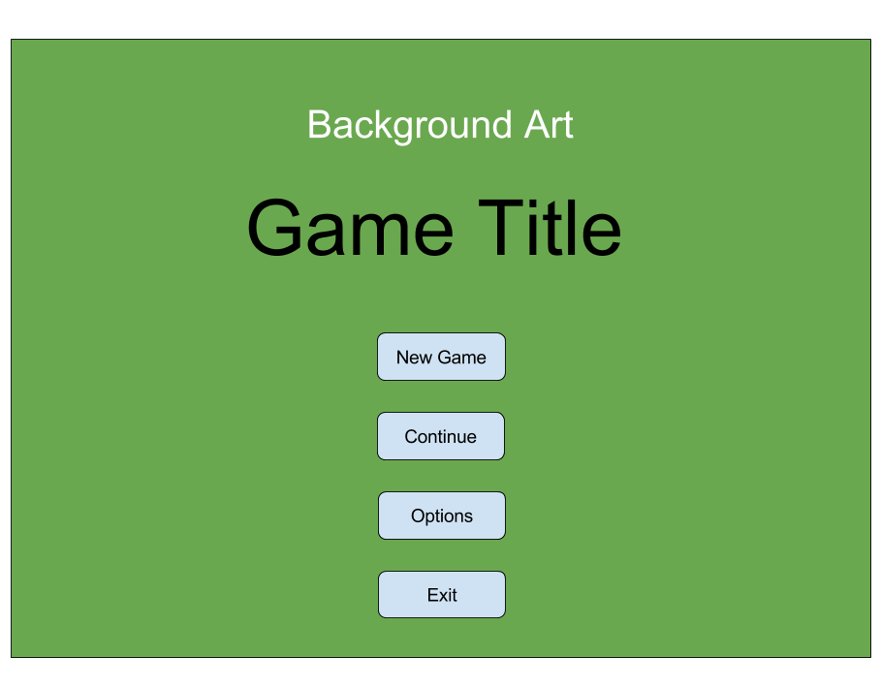New Game – Begins the game from the start, with no loaded data
* Load Game – Allows the player to load save data from a **list** of saved states, the preview will have the save name and a timestamp of the save, and there is currently no limit to the amount of save slots allowed.
* Options – From here the player may modify the options in game, the planned modifiable options are:
  + Resolution amount – standard Unity 5
  + Graphics setting – standard Unity 5
  + Fullscreen toggle – standard Unity 5
  + Music volume – Custom
  + SFX volume - Custom

## Cutscenes

Currently the only planned cutscene is a short 3 minute introduction where the two main characters speak to each other and set the scene for the game. The cutscene will be shown in the layout below, with a backdrop of a medieval town, and two main character sprites, speaking to each other using the dialogue box at the bottom of the screen.

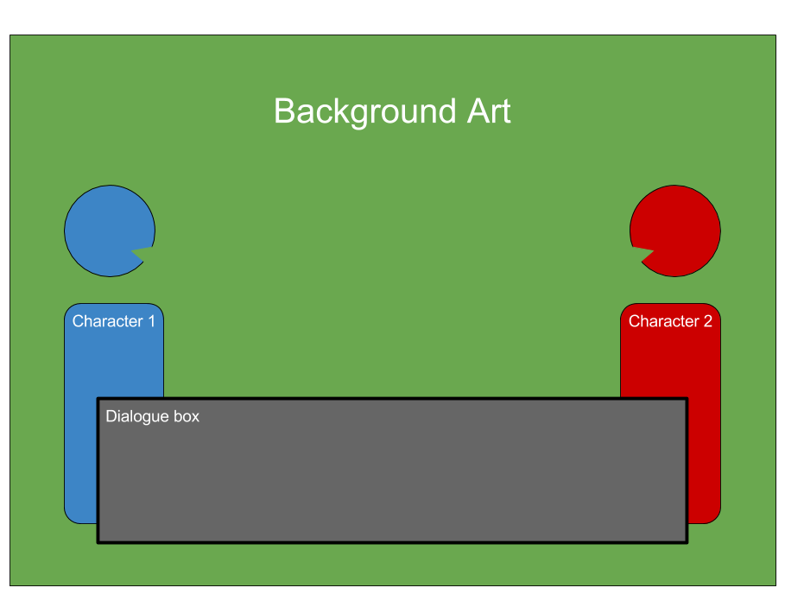

The important information to be covered is:

* Basic characterization of Janet and Steven
* What just happened (Janet saving Steven from thugs)
* Basic introduction of both characters
  + Janet: entrepreneur trader, in debt to the merchant’s guild, needs to trade goods in order to get gold and pay back debts
  + Steven: Acolyte of the Order, on a quest to protect the fiscally weak and economically ignorant.
* Why they should stick together: Janet needs the order’s trade connections and Steven needs the protection while on the road.
* Win and loss states: Janet must avoid missing a payment, Steven must increase his reputation in the Order by helping strangers.

## Overworld

The majority of the player time will be spent navigating the Overworld, and will be concerned with

* Overworld navigation with mouse or WASD, left-click to see info, right-click to move
* Simple auto-combat with no direct player input
* Players navigate towns by entering them like another hex
* Planned hexes are:
  + Forest – lumber production, hard to traverse, high risk (ambush)
  + Plains – farmland, ok to traverse, med risk
  + Hill – mining, hard to traverse, high risk (accident)
  + Lake – impassable
  + Road – great to traverse, no chance of loot, low risk
  + Town – serves as method to enter towns
* Any gain or loss of resources is automatically transferred
* Players may travel at night (6pm-6am), but risk is doubled

### Towns

* Towns are a series of windows, branching off from a hub, navigation is done with the mouse
* Players CANNOT transfer from house to house, must return to hub
* Visiting areas and conducting business consumes time, takes effect immediately.
* Planned houses are:
  + Barracks – Hire mercenaries or purchase weapons, reduces risk when travelling
  + Market – Sell or buy trade goods
  + Town Hall – See list of Quests
* Towns have a population that works and contributes to the economy
* Market price fluctuates based on input from town economy

### Quests

* Lvl 3 accounting quests require keyboard & mouse input, lvl1 & 2 require mouse only
* Successful quest will award gold & positive rep, failing a quest will award negative rep
* Players will be provided with a simple in-game calculator
* Switching to the Econonomicron from this screen will cause the player to forfeit some bonuses
* Every year of in-game time, the player will have to prepare a set of financial statements, based on the information recorded in the general journal, including:
  + Income Statement (Profit & Loss Statement)
  + Statement of Financial Position (Balance sheet)
* While it is not included in the syllabus, tax return preparation will be covered as it is a vital part of the system.

## Goals:

### Have positive cash-flow

* Players must maintain a positive net cash-flow as at the end of each month they will need to cover long-term liabilities, in ever-increasing amounts
* This is done through any activity that earns gold, although the system is set up that the player will have to trade in order to cover any debts
* Failure means the player is bankrupt and forfeits the game

### Earn Reputation

* Reputation determines what quests are available and what goods the player may buy.
* Players start at 0, the lowest possible amount, with only basic trade goods and quests available
* Having a reputation of 100 causes the player to win the game

### Avoid Disasters

* Players must practice appropriate risk-management when travelling
* Players may lose cargo due to ambush/hazard
* Cargo loss may inadvertently cause loss of game due to negative income

# Target Platform

PC & Mac – Standalone

Web Player, Android & IOS versions a desirable

# Aesthetics

<http://www.gamasutra.com/view/feature/185676/the_aesthetics_of_game_art_and_.php?print=1>

http://www98.griffith.edu.au/dspace/bitstream/handle/10072/29829/60667_1.pdf?sequence=1

<http://www.digra.org/wp-content/uploads/digital-library/09287.17350.pdf>

<http://www.cs.northwestern.edu/~hunicke/MDA.pdf>

<http://www.igea.net/wp-content/uploads/2015/07/Digital-Australia-2016-DA16-Final.pdf>

# Asset List

**Models:**

* Caravan Model
* Model of the Environment Hexes
  + Forest, Plains, Hills, Lake, Road, Town
  + Villager Model (Desirable)

**Textures:**

* Flat town Texture x 3
* Texturing for Hexes
  + Forest, Plains, Hills, Lake, Road, Town
* Caravan Texture
* Window Textures & borders
  + Quest, Barracks, Market
* Mountain Texture (Desirable)
* Desert Texture (Desirable)
* Ocean Texture (Desirable)
* Tooltip Portraits (Desirable)
  + Characters, Items, weapons

**Audio:**

* Overworld Music (loop)
* Town Music (loop)
* Battle Music (loop)
* Day/night Cycle prompt
* Selection sound (Desirable: section specific)
* Hover sound (Desirable: section specific)
* Desirable: NPC dialogue sound – Flavor text

**User Interface:**

* Selection window border
* Custom Cursor
* Custom Buttons
* Custom drop-down lists
* Thematic Typeface font

# Testing & Analytics:

Primary concerns:

* Is the game able to teach Year 11 Accounting (Teach as well as assess)?
  + **Player feedback:** what is the player’s age & perceived mastery of the material at the start vs. after the game
  + **Playtest Observations:** do they show moments of understanding when learning & can they apply that to the game.
  + **Metric:** Amount of incorrect vs. correct answers for Quests AFTER they learn it.
  + **Analysis:** Improve learning experience based on feedback.
* Does the game inform players on the economic theory through gameplay
  + **Player Feedback:** Do they understand the macro and micro economics at work.
  + **Playtest Observations:** Are they making sense of the way the world operates.
  + **Metric:** # successful trades
  + **Analysis:** modify the economic system (mechanics, GUI, ect) in light of feedback.
* Are the mechanics seamlessly interwoven into the experience
  + **Player Feedback:** How do they find the mechanics, are they tedious?
  + **Playtest Observations:** does the player make negative utterances at any point (groans of frustration or irritation)
  + **Metric**: Time spent on certain tasks vs. others
  + **Analysis**: Modify mechanics to ensure they meld with the experience.
* Is the UI easy to navigate
  + **Player** **Feedback**: How did they find the user interface design.
  + **Playtest** **Observations**: Do they spend too much time figuring out the UI or did they miss something
  + **Metric**: Amount of time spent on particular windows, or clicking on something that doesn’t work
  + **Analysis**: Modify the UI based on the user feedback, to ensure it is intuitive
* How long does the game hold the player’s attention
  + **Player Feedback**: How long did they think they were playing for vs. the actual playtime
  + **Playtest** **Observations**: how long till the player stops playing
  + **Metric**: Total playtime in a session, without pausing
  + **Analysis**: Attempt to analyses what is causing the player to leave, and act on it.
* What is the perceived difficulty of the game
  + **Player Feedback:** How hard were the questions
  + **Playtest Observations:** Are they having difficulty answering the questions
  + **Metric:** number of times players have to use the HINT function.
  + **Analysis:** Change questions based on player feedback
* Correlation between age and skill playing the game
  + **Player Feedback:** what is the player’s age & perceived mastery of the material overall
  + **Playtest Observations:** confidence when starting vs. actually playing the game
  + **Metric:** in-game questionnaire
  + **Analysis:** tailor questions to be more toward the target audience
* How effective is the game’s tutorial
  + **Player Feedback:** How difficult is the tutorial as a learning mechanism
  + **Playtest observations**: does the tutorial not teach enough of the game
  + **Metric**: how long does it take to clear the tutorial & do they have to repeat sections
  + **Analysis**: modify the tutorial based on feedback.

# Technical Considerations:

## Hardware:

* Desktop/Laptop PC – Must be capable of meeting the minimum specs for each of the development software.
* Keyboard – Standard
* Mouse – Standard
* Headphones – Standard
* Audio Equipment – (TBA by Sound Engineer)

## Software:

* Unity 5.3.4f1 – Game Engine, Free version
* Adobe Suite – Texturing & normal mapping, Student Version
* Quixel – Texturing, Student Version
* 3ds Max – Modelling software, Student version
* Audio software – (TBA by Sound Engineer)
* Github Desktop – Version control software, free version
* Slack – Communication software, free version
* Trello – Project management & scheduling, free version
* Firefox – Web browser, free version.